भारत मौसम विज्ञान विभाग |  | India Meteorological Department
Sunday 17th May 2026 (27th Vaisakha 1948 Saka)
Summary of observations recorded at 0830 hours IST: The Northern Limit of Monsoon continues to pass through 5°N/75°E, 6°N/79°E, 8°N/85°E, 10.5°N/90°E, 13.5°N/95°E, and 15.5°N/98°E. Conditions are favourable for further advance of southwest monsoon into some more parts of southeast Arabian Sea, southwest and southeast Bay of Bengal, remaining parts of Andaman Islands and Andaman Sea, and some parts of eastcentral Bay of Bengal during next 2-3 days. The Southwest Monsoon is likely to set in over Kerala on 26th May with a model error of ± 4 days. The low-pressure area over southwest & adjoining westcentral Bay of Bengal became less marked at 1730 hrs IST of yesterday, the 16th May 2026. However, the associated cyclonic circulation lay over southwest Bay of Bengal & adjoining Tamil Nadu extending upto 4.5 km above m. s. l. tilting southwestwards with height at 0530 hrs IST of today morning. It then lay over northeast Tamil Nadu and neighbourhood at 1.5 km above m. s. l. The upper air cyclonic circulation over south Rajasthan & neighbourhood lay over southeast Rajasthan Adjoining West Madhya Pradesh and extended upto 3.1 km above m. s. l. at 0530 hrs IST of today morning. It lay over West Madhya Pradesh and neighbourhood at 1.5 km above m. s. l. at 0830 hrs IST of today. The upper air cyclonic circulation over northeast Vidarbha & neighbourhood lay over west Vidarbha & neighbourhood at 0.9 km above m. s. l. An upper air cyclonic circulation lay over East Uttar Pradesh at 0.9 km above m. s. l. An upper air cyclonic circulation lay over Northeast Bihar at 0.9 km above m. s. l. An upper air cyclonic circulation lay over central Assam & neighbourhood at 0.9 km above m. s. l. An upper air cyclonic circulation lay over Comorin Area & neighbourhood at 3.1 km above m. s. l. A trough/ wind discontinuity ran from the cyclonic circulation over west Vidarbha & neighbourhood to Gulf of Mannar across Marathwada, interior Karnataka, and Tamil Nadu at 0.9 km above m. s. l. A fresh Western Disturbance seen as a cyclonic circulation over west Iran & neighbourhood at 5.8 km above m. s. l. at 0530 hrs IST of today morning. It lay over north Iran & neighbourhood at 5.8 km above m. s. l. The Western Disturbance as a cyclonic circulation over Jammu & adjoining north Pakistan became less marked at 0530 hrs IST of today morning. However, the trough in westerly in middle tropospheric westerlies with its axis at 5.8 km above m. s. l. ran roughly along Long. 92°E to the north of Lat. 26°N moved away east-northeastwards. The upper air cyclonic circulation over east Rajasthan & neighbourhood at 0.9 km above m. s. l. merged with the upper air cyclonic circulation over southeast Rajasthan Adjoining West Madhya Pradesh at 0530 hrs IST of today morning. The east-west trough from north Bihar to south Assam across North Gangetic West Bengal became less marked. The upper air cyclonic circulation over central Uttar Pradesh & neighbourhood became less marked at 0530 hrs IST of today morning. The upper air cyclonic circulation over northwest Uttar Pradesh & adjoining Uttarakhand became less marked at 0530 hrs IST of today morning.
Maximum Temperature Departures (as on 16-05-2026): markedly above normal (> 5.1°C) at few places over East Madhya Pradesh; at isolated places over West Uttar Pradesh, East Rajasthan and West Madhya Pradesh. appreciably above normal (3.1°C to 5.0°C) at few places over Gujarat Region; at isolated places over Gangetic West Bengal, East Uttar Pradesh, Himachal Pradesh, Madhya Maharashtra and Vidarbha. above normal (1.6°C to 3.0°C) at many places over Marathwada; at few places over Saurashtra & Kutch and North Interior Karnataka; at isolated places over Andaman & Nicobar Islands, Odisha, Bihar, Uttarakhand, West Rajasthan, Konkan & Goa, Coastal Andhra Pradesh & Yanam and Telangana. near normal (-1.5°C to 1.5°C) at many places over Nagaland, Manipur, Mizoram & Tripura, Sub Himalayan West Bengal & Sikkim, Punjab and Coastal Karnataka; at most places over Assam & Meghalaya, Jharkhand, Haryana-Chandigarh-Delhi, Jammu-Kashmir-Ladakh-Gilgit-Baltistan-Muzaffarabad, Rayalaseema and South Interior Karnataka; at few places over Tamil Nadu, Puducherry & Karaikal; at isolated places over Chhattisgarh and Kerala & Mahe. The highest maximum temperature of 46.0°C was reported at Amraoti & Wardha (Vidarbha).
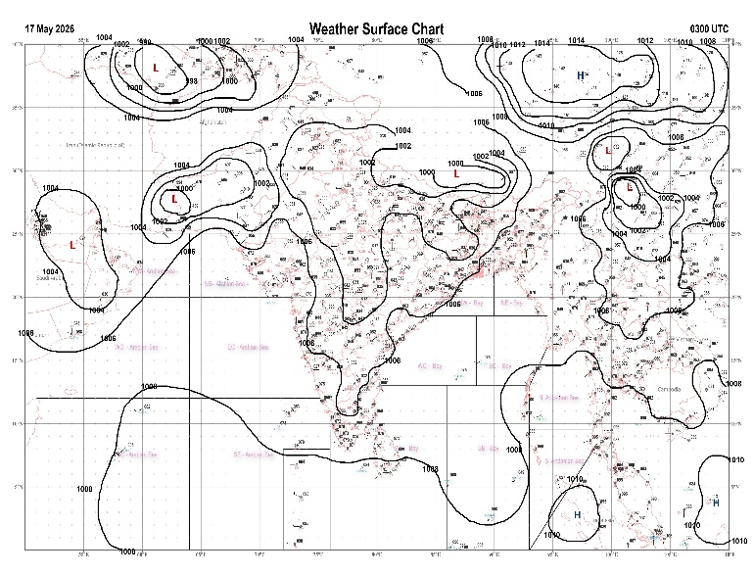 | 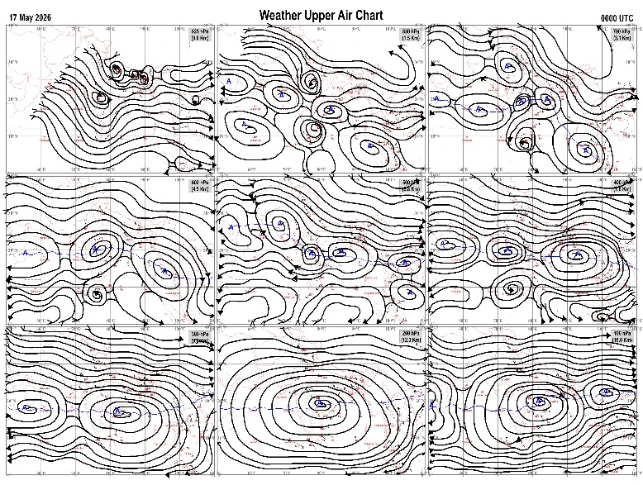
Fig.1. Analysed surface chart based on 03z observation | Fig.2. Analysed upper air chart based on 00z observation
Dr. S.D.Sanap
Scientist ‘D’
CR & S Office, Pune  Issued at 1245 hrs. IST |  | Weather Forecasting Division  CR&S, Pune

Indian regions | Realised rainfall (chief amount in cm during past 24 hrs):
East | most places: Sub-Himalayan West Bengal & Sikkim+++  many places: Arunachal Pradesh+, Assam & Meghalaya+ and Nagaland-Manipur-Mizoram-Tripura  isolated places: Gangetic West Bengal, Odisha+, Jharkhand and Bihar  Indong t.e. 14.0, Hilla t.e. 13.0, Gurundia 9.4, Cherrapunji (rkm) 8.8, Banaigarh 8.6, Tuting 8.5, Balurghat 8.0, Dhemaji 7.5, D / Mohanbari AP 6.8, Itanagar 4.9, Sonamura 4.0, Lembuchhera 3.7, Pasighat AP 2.6, Manjhari 1.8, Burdwan PTO 1.6, Baisa 1.5, Sikti 1.2, Agartala AP 1.0, Mankar, Burnpur & Bhawanipatna 0.9 each, Maithon dvc 0.7.
North | isolated places: Uttarakhand, Himachal Pradesh and Jammu-Kashmir and Ladakh  dry weather: Uttar Pradesh, Haryana, Punjab and Rajasthan  Jakholi 2.8, Uttar kashi & Sarahan 1.9 each, Pauri 0.5, Bandipora 0.3, Chamba AWS 0.2, Pahalgam AWS & Badarwah 0.1 each.
Central | isolated places: east Madhya Pradesh, Vidarbha and Chhattisgarh  dry weather: west Madhya Pradesh  Raipur 6.3, Bade bacheli 4.2, Barsur 4.0, Amarkantak 3.6, Tiroda (ARG) 1.9, Ghansore 0.8, Sidhi (gopadbanas) 0.4, Mauda 0.3.
Peninsula | many places: coastal Karnataka+  a few places: south interior Karnataka and Kerala+  isolated places: Konkan & Goa◆, Telangana, Rayalaseema, Tamil Nadu+ and north interior Karnataka  dry weather: Gujarat State, Madhya Maharashtra, Marathwada and coastal Andhra Pradesh  Kayamkulam ARG 10.6, Cherthala 7.5, Suthamalli dam 6.7, Mulki 6.6, Navalur kottapattu 6.5, Haveri PTO 4.6, Jadcherla 4.2, Kollapur 4.1, Mudubidre & Shivamogga PTO 4.0 each, Navile AWS 3.9, Hunchadakatte 3.8, Koppal PTO 2.2, Gonegandla & Yemmiganur 1.6 each, Karambakudi 1.5, Honavar 1.4, Kurnool & Shirahatti 1.0 each, Kottayam 0.8, Mahbubnagar 0.6, Dabolim n.a.s. navy 0.2.
Islands | many places: Andaman & Nicobar and Lakshadweep  Maya bandar 5.4, Minicoy 2.6, Port blair 1.7, Long island 0.7, Amini 0.6, Agathi 0.1.
Table-2 Forecast / warnings (distribution of rain / thundershowers) for 7 days (valid from time of origin upto 0830 hrs IST of next day)
Sr N. |  | Sub-division Name | Day 1 | Day 2 | Day 3 | Day 4 | Day 5 | Day 6 | Day 7 | Sr. No. | Sub-division Name | Day 1 | Day 2 | Day 3 | Day 4 | Day 5 | Day 6 | Day 7
 |  |  | 17 May | 18 May | 19 May | 20 May | 21 May | 22 May | 23 May |  |  | 17 May | 18 May | 19 May | 20 May | 21 May | 22 May | 23 May
 | 1 | Andaman Nicobar Islands | W ++  | W +  | W +  | W +  | W +  | W +  | W +  | 19 | west Madhya Pradesh | D  + | D + | D + | D + | D + | D | D
 | 2 | Arunachal Pradesh | W ++  | F +  | S | S | S | W | W | 20 | east Madhya Pradesh | I  + | D + | D + | D + | D + | D | D
 | 3 | Assam-Meghalaya | W ++ | F+  | S  | S +  | F + | W ++ | W++ | 21 | Gujarat region | D | D | D | D | D | D | D
 | 4 | Nagaland-Manipur-Mizoram-Tripura | F +  | F +  | S +  | S +  | F + | F + | F + | 22 | Saurashtra and Kutch | D | D | D | D | D | D | D
 | 5 | Sub Him West Bengal/Sikkim | W ++  | F  | S  | F  | W +  | W +  | W +  | 23 | Konkan and Goa | I  | I | I | I | I | I | I
 | 6 | Gangetic West Bengal | S  | I  | S  | I | I | I | I | 24 | Madhya Maharashtra | I  | I  | D | D | D | D | D
 | 7 | Odisha | I  | I  | I  | I  | I  | I  | I  | 25 | Marathwada | D + | D + | D | D | D | D | D
 | 8 | Jharkhand | I  | I  | I  | S  | I  | I | I | 26 | Vidarbha | I+ | D+ | D + | D + | D + | I | I
 | 9 | Bihar | I  | D | I  | S  | I  | I | I | 27 | Chhattisgarh | I  | I  | D | D + | D + | D | D
 | 10 | east Uttar Pradesh | D + | D + | D + | I + | I + | I + | I+ | 28 | Coastal Andhra Pradesh and Yanam | I  | I  | I  | I  | I  | I | I
 | 11 | west Uttar Pradesh | D + | D + | D + | D + | D + | D+ | D+ | 29 | Telangana | I + | D + | D + | D + | D + | D | D
 | 12 | Uttarakhand | I  | D | D | I  | I  | I | I | 30 | Rayalaseema | I  | I  | I  | I  | I  | I | I
 | 13 | Haryana,Chandigarh and Delhi | D | D + | D + | D + | D + | D+ | D+ | 31 | Tamil Nadu, Puducherry and Karaikal | I  | I  | I | S | S | S | I
 | 14 | Punjab | D | D + | D + | D + | D + | D + | D+ | 32 | Coastal Karnataka | S+ | S +  | S+ | S  | S  | I | I
 | 15 | Himachal Pradesh | I | I | I  | I  | I  | S | S | 33 | North interior Karnataka | I  | I  | I  | I  | I  | D | D
 | 16 | Jammu-Kashmir and Ladakh | D | I | S  | S  | S | I | I | 34 | South interior Karnataka | S+ | S+ | S+ | S  | S  | I | I
 | 17 | west Rajasthan | D + | D + | D + | D + | D + | D + | D+ | 35 | Kerala and Mahe | W++ | W +  | W+ | F  | F  | F | F
 | 18 | east Rajasthan | D + | D + | D + | D + | D + | D+ | D+ | 36 | Lakshadweep | W+ | W +  | W | F | F | F | F
Legends: D = Dry I =isolated S = Scattered F = Fairly widespread W = Widespread #= heavy to very heavy rain at a few places with extremely heavy rain at isolated places+++= heavy rain at a few places with very heavy rain at isoIated places++= heavy to very heavy rainfall @=isolated exceptionally heavy rainfall+ = heavy rain ●/*= rain or snow ♦ = very light rain ≡=fog = thunderstorm with lightning =Squall / Gusty / gale / strong wind -=cold wave/cold day + = heat wave/warm night/hot and humid weather =Duststorm =ground frost = Hail.

Fig. 4: Districtwise warnings for five days for Maharashtra State
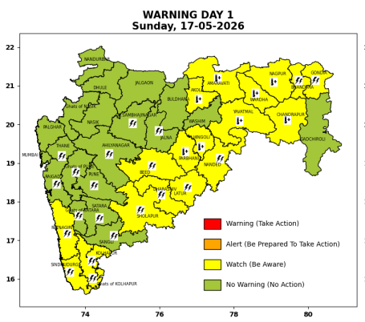 | 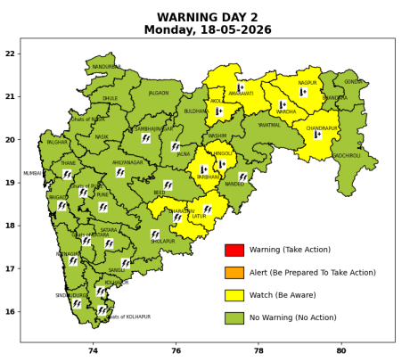 | 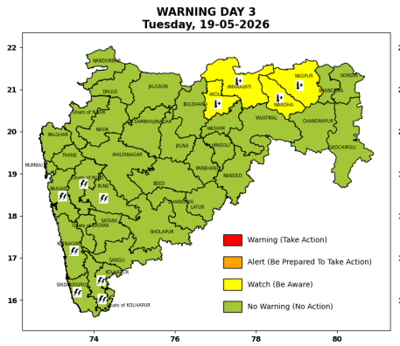 | 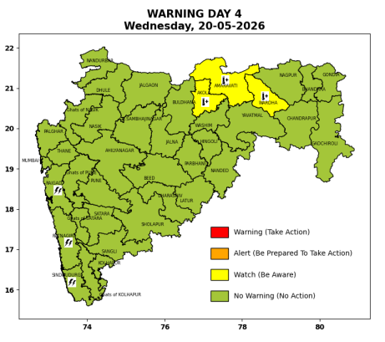 | 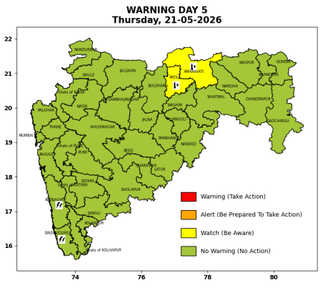

Pune, Lohegaon and Pashan observations at 0830 hrs. IST of Today
 | Temperature (°C) |  |  |  |  | Humidity (%) |  |  |  | Rainfall (mm)
 | Max.  past  24 hrs | Dep.  from  normal | Min.  past  24 hrs. | Dep.  from  normal | Dry  Bulb | At 0830 hrs. IST | Dep.  From  normal | At 1730  hrs. IST of y’day | Dep.  from  normal | Past  24 hrs. | Since  1st March | Dep.  from  normal
PNE | 39.2 | 2.3 | 25.5 | 2.1 | 28.4 | 66 | 6 | 32 | -6 | 0.0 | 92.8 | 66.1
PSN | - | - | - | - | - | - | - | - | - | - | - | -
LHG | 40.8 | 3.8 | 27.3 | 6.3 | 29.2 | 56 | -4 | 30 | -6 | 0.0 | 91.4 | 59.4

 |  |  |  |  |  |  | Local (Pune and neighbourhood) forecast
Max./Min. Temperature (°C) |  |  |  |  |  |  |  |  | Weather
Date | Pune | Pashan | Lohegaon | Chinchwad | Lavale | Magarpatta | NDA | Koregoan park
17/05/26 | 39 / 25.5* | 39 / - | 40 / 27.3* | 39 / 25.8* | 38 / 22.6* | 39 / 27.2* | 37 / 25.2* | 40 / 27.2* | Mainly clear sky becoming partly cloudy sky towards afternoon or evening. Thunderstorm with lightening, very light rain very likely.
18/05/26 | 39 / 25 | 39 / 25 | 41 / 27 | 39 / 26 | 38 / 23 | 39 / 27 | 38 / 25 | 40 / 27 | Mainly clear sky becoming partly cloudy sky towards afternoon or evening. Thunderstorm with lightening, very light rain very likely.
19/05/26 | 38 / 24 | 38 / 24 | 40 / 26 | 38 / 25 | 37 / 22 | 38 / 26 | 37 / 24 | 38 / 27 | Mainly clear sky becoming partly cloudy sky towards afternoon or evening.
20/05/26 | 37 / 23 | 37 / 23 | 39 / 25 | 37 / 25 | 36 / 22 | 37 / 26 | 37 / 24 | 38 / 26 | Mainly clear sky becoming partly cloudy sky towards afternoon or evening.
21/05/26 | 37 / 23 | 37 / 23 | 38 / 25 | 37 / 24 | 36 / 22 | 37 / 25 | 36 / 23 | 38 / 25 | Mainly clear sky becoming partly cloudy sky towards afternoon or evening.
22/05/26 | 37 / 23 | 37 / 23 | 38 / 25 | 37 / 24 | 36 / 22 | 37 / 25 | 36 / 23 | 37 / 25 | Mainly clear sky becoming partly cloudy sky towards afternoon or evening.
23/05/26 | 37 / 23 | 37 / 23 | 38 / 25 | 37 / 24 | 36 / 22 | 37 / 25 | 36 / 23 | 37 / 25 | Mainly clear sky becoming partly cloudy sky towards afternoon or evening.
Rainfall Distribution |  |  |  |  | Rainfall Categories | Rainfall (mm) | Cloud condition |  | Rainfall Intensity | Range
Widespread (W) | 76-100% |  |  |  | Very Light rain | Trace to 2.4 mm | Mainly clear sky | 1-2 oktas | Light Spell | 1 cm/hr
 |  |  |  |  | Light rain | 2.5 to 15.5 mm | Partly cloudy sky | 3-4 oktas | Moderate Spell | 1-2 cm/hr
Fairly Widespread (FW) | 51 – 75% |  |  |  | Moderate rain | 15.6 to 64.4 mm | Generally cloudy sky | 5-7 oktas | Intense Spell | 2-3 cm/hr
Scattered (S) | 26 – 50% |  |  |  | Heavy rain | 64.5 to 115.5 mm | Overcast | 8 oktas | Very Intense Spell | 3-5 cm/hr
Isolated (I) | 1 – 25% |  |  |  | Very heavy rain | 115.6 to 204.4 mm |  |  | Extremely Intense Spell | 5-10 cm/hr
Dry (D) | No Rain |  |  |  | Extremely heavy rain | ≥ 204.5 mm |  |  | Cloudburst | > 10 cm/hr
Probability Terms in %: |  |  |  |  | Heavy snow | 6.5 to 11.5 cms water equivalent of rain
unlikely | < 25 |  |  |  | Very heavy snow | 11.6 to 20.4 cms water equivalent of rain
likely | between 25 50
very likely | between 51 75
most likely | >75
* = realized temperatu
Mumbai (Colaba) |  |  |  | Nagpur (AP)
Date 2026 | T max °C | T min °C | Weather | T max °C | T min °C | Weather
17/05/26 | 34 | 28 | Clear sky. | 45 | 26 | Heat Wave.
18/05/26 | 34 | 28 | Clear sky. | 45 | 26 | Heat Wave.
19/05/26 | 33 | 28 | Clear sky. | 45 | 26 | Heat Wave.
20/05/26 | 33 | 28 | Clear sky. | 44 | 27 | Heat Wave.
21/05/26 | 33 | 28 | Clear sky. | 44 | 27 | Heat Wave.
22/05/26 | 33 | 28 | Clear sky. | 43 | 26 | Heat Wave.
23/05/26 | 33 | 28 | Clear sky. | 43 | 26 | Mainly clear sky.

